Maiden Choice School

Baltimore County (03:0111)

 | School |  | County |  | State
Attendance Rate % | 2016 | 2015 | 2016 | 2015 | 2016 | 2015
Elementary | 86.4 | 90.6 | > 95% | > 95% | 95.6 | 95.4
Middle | 89.4 | 87.7 | > 95% | 94.8 | 95.1 | 95.0
High | 86.3 | 82.7 | 92.2 | 92.1 | 92.4 | 92.4
Cohort Graduation Rate%
2016 (4-Year Rate) | * |  | 89.17 |  | 87.61
2015 (4-Year Rate) | * | * | 89.15 | 87.78 | 89.11 | 86.98
2015 (5-Year Rate)

 | Teacher Qualifications | School |  | County |  | State
 |  | 2016 | 2015 | 2016 | 2015 | 2016 | 2015
 | % of certificates: | 15.4 |  | 26.4 |  | 25.6
 | Standard Professional |  | 28.6 |  | 28.2 |  | 27.4
 | Advanced Professional | 69.2 | 71.4 | 62.6 | 66.9 | 61.9 | 65.2
 | Resident Teacher | 0.0 | 0.0 | 0.3 | 0.3 | 1.0 | 1.1
 | Conditional Teacher | 7.7 | 0.0 | 1.5 | 1.7 | 1.5 | 1.5
 | % of classes NOT taught by highly qualified teachers
 | All Quartiles | 16.7 | 22.4 | 7.9 | 7.4 | 8.9 | 8.4
 | Elementary Low Poverty | * | * | 3.0 | 2.7 | 3.3 | 2.9
 | Elementary High Poverty | * | * | 2.8 | 0.6 | 11.2 | 10.5
 | Secondary Low Poverty | * | * | 10.2 | 8.7 | 7.0 | 6.7
 | Secondary High Poverty | * | * | 10.5 | 12.4 | 17.1 | 17.7

͞Ύ͟ indicates no students or fewer than 10 students in category.

Attendance Rate

Attendance Rate is the percentage of students in school for at least half of the average school day during the school year. Yearly targets were set for attendance so that by the end of school year 2013-14, the State, schools, and school systems would achieve and maintain an attendance rate of at least 94 percent.

Cohort Graduation Rate

The U.S. Department of Education requires each state to use an adjusted cohort graduation rate for school accountability. The adjusted cohort graduation rate ensures that all students who entered 9th grade together are counted in the graduation rate at the end of 4 years and at the end of 5 years.

The cohort graduation rate data for 2016 is the 4-year rate for the student cohort entering grade nine for the first time in fall 2012 and graduating no later than 2016. The cohort graduation rate data for 2015 is the 4-year rate for the student cohort entering grade nine for the first time in fall 2011 and graduating no later than 2015. The 2015 5-year rate is the same cohort graduating no later than 2016.

Teacher Qualifications

The percentage of teachers in each category is based on the number of teachers who have credentials and are teaching core academic subjects as defined by the federal government under the Elementary and Secondary Education Act (ESEA) as modified by the No Child Left Behind Act (NCLB). The core academic subjects are English, reading or language arts, mathematics, science, world languages, civics and government, economics, arts, history, and geography. Teachers who are teaching other subjects are not included in the totals.

Standard Professional Certificate: A Standard Professional Certificate indicates the teacher meets all certification requirements.

Advanced Professional Certificate: The Advanced Professional Certificate requires three years of satisfactory professional school-related experience, and a master͛s degree or a minimum of 36 semester hours of post baccalaureate course work.

Resident Teacher Certificate: The Resident Teacher Certificate is issued to a teacher in an approved alternative preparation program at the request of a local school system superintendent.

Conditional Teacher Certificate: The Conditional Certificate is issued only at the request of a local school system superintendent to an applicant who has a bachelor͛s degree but does not meet all certification requirements.

Highly Qualified Teachers: ͞Highly qualified͟ is specifically defined by federal law. Teachers must meet minimum requirements both in content knowledge and teaching skills. Teachers must have a bachelor͛s degree, full State certification, and demonstrate content knowledge in the subjects they teach.

School Progress and Annual Measurable Objectives (AMOs)

On December 10, 2015, President Obama signed the Every Student Succeeds Act (ESSA). In accordance with the U.S. Department of Education's (USED) authority to ensure an orderly transition to ESSA, USED will not require States to identify AMOs for school years 2014-2015 or 2015-2016 for USED's review and approval, nor will USED require States to report performance against AMOs for the 2014-2015 or 2015-2016 school years.

Due to this direction, Maryland will not measure LEAs and schools against AMOs.

Visit Report.msde.maryland.gov for up-to-date and disaggregated information.

Maiden Choice School

MSA Science Proficiency Levels
Basic % | Proficient % Advanced %
SCHOOL % | COUNTY %
GRADE
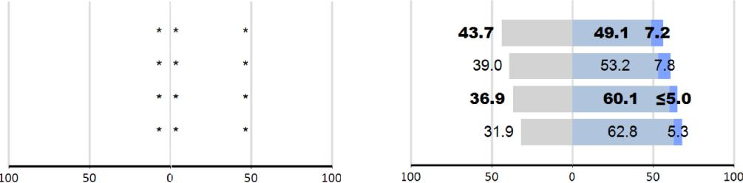
5 2016

Science | 2015
 | 8 2016
 | 2015

Alt-MSA Science Proficiency Levels
Basic % Proficient % Advanced %

 |  | SCHOOL % | COUNTY %
Science | GRADE
 | 5 | 2016
 |  | 2015
 | 8 | 2016
 |  | 2015

͞Ύ͟ indicates no students or fewer than 10 students in category.

STATE %
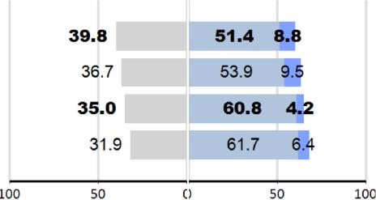

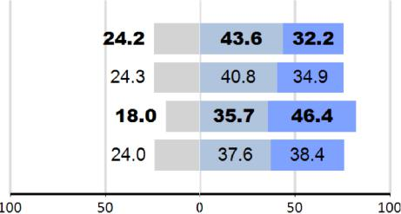
STATE %

Maryland School Assessment (MSA) Science

The MSA measures what students in grades 5 and 8 know about Science. High school performance is measured by the Biology* High School Assessment (HSA). Performance is reported as the percent of students in each grade who achieved the Basic, Proficient, or Advanced standard. All students should be achieving at the Proficient or Advanced standard.

* Data not available at date of publication.

Alternate Maryland School Assessment (Alt-MSA) Science

The Alternate Maryland School Assessment (Alt-MSA) is taken by students with disabilities who cannot take the MSA or PARCC in science even with the special accommodations they receive as part of their regular classroom instruction. The test measures the student͛s mastery of Science content standards or appropriate access skills. Eligible students take the test in grades 3-8 and once during the high school grade band*. Performance is reported as the percent of students in each grade who achieved the Basic, Proficient, or Advanced standard.

Description of Proficiency Levels

Basic %

Science:

Students show they need more work to attain proficiency. They use minimal supporting evidence/responses provide little or no synthesis of information.

Advanced % Proficient %
Students use supporting evidence that is generally complete with some integration of scientific concepts, principles, and/or skills.

Students use scientific evidence to demonstrate a full integration of scientific concepts, principles, and/or skills.

Visit Report.msde.maryland.gov for up-to-date and disaggregated information.

Maiden Choice School

PARCC Assessment Performance Results Summary - 2016

Performance Level

 | Level 1 |  |  | Level 2 |  |  | Level 3 |  |  | Level 4 |  |  | Level 5
 | Did not yet meet |  |  | Partially met |  |  | Approached |  |  | Met expectations |  |  | Exceeded
 | expectations |  |  | expectations |  |  | expectations |  |  |  |  |  | expectations
TESTED | Count |  | % | Count |  | % | Count |  | % | Count |  | % | Count |  | %

Partnership for Assessment of Readiness for College and Careers (PARCC)

Students in grades 3-8 and high school participated in the PARCC assessments in English Language Arts and Mathematics. PARCC complements, but does not replace, the existing Maryland School Assessment Program. Performance in science in grades 5 and 8, the Alternate Maryland School Assessment (for students with disabilities), and, the Maryland High School Assessments in Biology and Government continue to be a part of the Maryland School Assessment Program.

PARCC Performance Level Descriptors (PLD)

Performance level descriptors for English language arts/literacy and Mathematics describe what a typical student at each level should be able to demonstrate based on his/her command of grade-level standards.

Level 1: Did not yet meet expectations

Level 2: Partially met expectations

Level 3: Approached expectations

Level 4: Met expectations

Level 5: Exceeded expectations

Visit Report.msde.maryland.gov for up-to-date and disaggregated information.

Maiden Choice School

PARCC Assessment Participation Results Summary - 2015 & 2016

 |  | 2015 |  |  | 2016
Assessment | Student | Participation | Participation | Student | Participation | Participation
 | Count | Count | Rate | Count | Count | Rate

Visit Report.msde.maryland.gov for up-to-date and disaggregated information.

This table displays the participation rate in English Language Arts and mathematics based on the PARCC assessments. Data show the number of students eligible to take the assessment (student count), the number of students who participated in the assessment (participation count), and the percentage of those students participating (participation rate) for 2015 and 2016.

Visit Report.msde.maryland.gov for up-to-date and disaggregated information.

